-

Team members

*(Team Leader)* Jonathan Leathem 40059090

Steven Kennedy 40025827

Conor McAleavey 40047330

Chris McClune 40138365

Kevin O’Hare 15481042

Abstract

We intend to design and develop an educational application aimed at children ages three to seven. This application will follow a level-based format and shall quiz children on a range of subject areas. Mathematics, English, Geometrics and Science will be the main subject focus of our application.

Team Report

Web and Mobile App Development Group Project CSC7054

Project title

Children’s Educational Quiz App

Table of Contents

**1. Project Proposal and Introduction 2**

**2. Customer Statement of Requirements 2**

2.1 Problem Statement 2

2.2 Glossary of Terms 3

**3. System Requirements 3**

3.1 Functional Requirements 3

3.2 Non-Functional Requirements 4

**4. Functional Requirements Specification 6**

4.1 Stakeholders 6

4.2 Actors and Goals 6

4.3 Use Cases 6

4.4 System Sequence Diagrams 8

**5. User Interface Specification 8**

5.1 Preliminary Design 8

5.2 User Effort Estimation 9

**6. Domain Analysis 10**

6.1 Domain Model 10

6.2 System Operation Contracts 10

6.3 Mathematical Model 10

**7. Case Study 11**

**8. Plan of Work 11**

**9. References 12**

**10. Appendix 13**

1. **Project Introduction and Proposal**

We intend to design and develop an educational application aimed at children ages three to seven. This application will follow a level-based format and shall quiz children on a range of subject areas. Mathematics and Numeracy, Geometrics and Science, English and Literacy, will be the main subject focus of our application.

In order to successfully target our defined age groups, we shall closely follow the Northern Ireland Curriculum Framework for Early Years Foundation Stage (EYFS) and Key Stage 1 (KS1). Applying this framework to our quiz questions will ensure our application meets the minimum requirements on education, set by the UK government, following the introduction of the Education Reform Act (1988).

It is our intention to develop a multi-layer scoring system. Unlike many other quiz apps on the market - which only score users based on the number of correct answers - our application will also take into account the length of time spent by the user on each question and award an adjusted score accordingly. Opportunities for bonus points may also be implemented. The app will incorporate different input methods, including, but not limited to; multiple choice, fill-in-the-blanks and text input.

We aim to use a database to store a user’s personal high scores for each level, and separately, the high scores of other users. Furthermore, based on the user’s high scores per level, they may be awarded bronze, silver, or gold medals, as a way of rewarding the users and encouraging them to gain higher scores, which in turn should help educate them.

Targeting a young demographic, we are conscious of the importance of ensuring our application adopts a vibrant and playful experience, whilst maintaining its underlying usefulness as an educational quiz application. Finding the optimal balance between the learning experiences offered and the visual effects on show, will go a long way in determining how well our application is accepted by our primary stakeholders.

In short, the fundamental goal of this application, is to create a quiz that helps children to learn core foundational skills, in key subject areas, based on their age, in an environment that the user will find fun and engaging.

The “Quiz for Kids” product was created and owned by Steven Kennedy, Jonathan Leathem, Conor McAleavey, Chris McClune, and Kevin O’Hare. All members are students of Queen’s University, Belfast and have completed this project as part of the Web and Mobile App Development module of MSc Software Development.

1. **Customer Statement of Requirements (CSR)**
   1. **Problem Statement**

I am a middle-aged woman from Belfast, with two children, aged four and six respectively. They have started primary school recently, and are getting along well. However, at home, they spend a lot of time playing on their tablet and I am worried that this could be distracting them from their homework. I believe that if they were spending time on a fun, but educational app while using their tablet, it would benefit them in school, engage them with their education, whilst making learning a more enjoyable experience for them.

This application should be aimed at children who are old enough to operate a tablet or smartphone, but still learning basic maths and English, among other skills at a primary school level. It should quiz children on subject-specific areas, reflecting what they are be taught in school at their age. Therefore, it would be helpful if the quizzes could be divided into distinguishable difficulty levels, based on the child’s age.

A scoring system that could be understood and interpreted by children would be helpful. For instance, if it could identify which questions they got correct and which they got incorrect – then this should benefit the child’s learning experience. Also, there should be a timer on each question to prevent them from simply going off and looking up the answer. Awarding bonus points for answering questions correctly in less time, may also motivate the children. Based on their high scores per level they may be awarded bronze, silver or gold medals as a way of rewarding them and encouraging them to gain higher scores, which in turn will educate them.

* 1. **Glossary of Terms**

A sequence diagram describes object interaction and lays emphasis on message sequence. In other words, it shows how message send and receive among the objects. There are two coordinate axes, y-axis is time and x-axis is object. (Schmuller, 2004)

User-interface navigation refers to the mouse clicks or keystrokes needed to navigate through different windows of the user interface until you reach the appropriate context where you can enter the data. (Context roughly corresponds to the window in which the data entry will take place.) <http://www.ece.rutgers.edu/~marsic/Teaching/SE1/report1-appA.html>

Clerical data entry refers to the mouse clicks or keystrokes needed to enter data into your system, once you're already in the appropriate context (the window that you reached by navigation) <http://www.ece.rutgers.edu/~marsic/Teaching/SE1/report1-appA.html>

1. **System Requirements**

**3.1. Functional Requirements**

|  |  |  |
| --- | --- | --- |
| **No.** | **Description** | **Priority Weight** |
| 1 | Upon opening the application, the user shall be directed to the *Home* page. | High |
| 2 | Upon selecting the ‘PLAY’ button on the *Home* page, the user shall be directed to the *Select Age* page. | High |
| 3 | Upon selecting either the ‘3-5YRS’ button or the ‘5-7YRS’ button on the *Select Age* page, the user shall be directed to the *Select Level* page which corresponds to their age. | High |
| 4 | Upon selecting the ‘LEVEL 1’ button, the ‘LEVEL 2’ button, or the ‘LEVEL 3’ button on the *Select Level* page, the user shall be directed to the first *Question* page corresponding to the user’s selected age group and level. | High |
| 5 | Upon selecting an answer to a question on the *Question* page the selected button shall change colour from yellow to red. Selecting a different answer shall change the colour of that button to red and revert the colour of the previously selected button to yellow. | High |
| 6 | The first time the user selects an answer on the *Question* page, a red arrow pointing to the right shall appear in the bottom right corner. Selecting this arrow shall confirm the user’s selection of answer and shall direct the user to the next question. | High |
| 7 | Upon selecting the red arrow on the *Question* page for the final question the user shall be directed to the *Results* page. | High |
| 8 | Upon selecting the red arrow on the *Results* page the user shall be directed to the *Home* page. | Medium |
| 9 | Upon selecting the ‘HIGHSCORES’ button on the *Home* page, the user shall be directed to the *High Scores* page. | High |
| 10 | Upon selecting the ‘ON’ button on the *Home* page, the music shall turn on and the ‘OFF’ button shall be toggled off. | Medium |
| 11 | Upon selecting the ‘OFF’ button on the *Home* page, the music shall turn off and ‘ON’ button shall be toggled off. | Medium |
| 12 | Upon selecting the ‘VIDEO HELP DESK’ button in the *Home* page, the user shall be directed to the *Video Help Desk* page. | High |
| 13 | Upon selecting the play button on the *Video Help Desk* page, a video tutorial for the *Quiz for Kids* application shall begin to play. | High |
| 14 | Upon selecting the pause button on the *Video Help Desk* page, the video tutorial shall pause. | High |
| 15 | Upon selecting the full screen button on the *Video Help Desk* page, the video shall expand to the full screen of the device. | High |
| 16 | While the video is in full screen mode, selection of the minimize screen button shall revert the display of the video back to its initial state. | High |

**3.2. Non-Functional Requirements**

|  |  |  |
| --- | --- | --- |
| **No.** | **Description** | **Priority Weight** |
| 17 | The application shall consist of the following pages: *Home, Select Age,* two *Select Level* pages*,* a number of *Question* pages (based on each age and level combination and number of questions for each quiz), *Results,* *Select Age – High Scores,* two *High Scores* pages*,* and *Video Help Desk.* | High |
| 18 | The *Home* page shall consist of the application logo at the top of the page with a button below it labelled as ‘PLAY’ followed by another labelled ‘HIGHSCORES’. Below this shall be a text view reading ‘MUSIC:’ adjacent to two buttons labelled ‘ON’ and ‘OFF’. There shall be another button below this labelled ‘VIDEO HELP DESK’. The logo and the buttons shall all be aligned along the vertical centre. | High |
| 19 | Music shall play throughout the application while the ‘ON’ button is toggled on. | Medium |
| 20 | The *Select Age* page shall consist of the application logo at the top of the page with a text view instructing the user to select their age group below it. Below the text view shall be a button labelled as ‘3-5YRS’ followed by another button labelled ‘5-7YRS’. The logo, text view, and buttons shall all be aligned along the vertical centre. | High |
| 21 | The *Select Level* pages shall consist of the application logo at the top of the page with three buttons labelled as ‘LEVEL 1’, ‘LEVEL 2’, and ‘LEVEL 3’ below it. The logo and the buttons shall all be aligned along the vertical centre. | High |
| 22 | Upon first use of the application, only the ‘LEVEL 1’ button shall be enabled. Completing ‘LEVEL 1’ successfully shall enable the ‘LEVEL 2’ button and completing ‘LEVEL 2’ successfully shall enable the ‘LEVEL 3’ button. | High |
| 23 | The *Question* pages shall consist of a question at the top of the page with an image below to accompany it. Four buttons shall be aligned 2x2 below the image labelled as potential answers to the question. A red arrow shall appear in the bottom right corner after the user has selected one of the buttons. | High |
| 24 | The *Question* pages shall also have a countdown timer displayed in the top right corner of the page. The timer shall have a duration of 30 seconds starting as soon as the user opens the page. Once this timer reaches zero the user shall be unable to score any points for the question they are on. | High |
| 25 | The *Results* page shall consist of a text view at the top of the page labelled ‘RESULTS’ aligned along the vertical centre. Below this and on the left side of the page shall be the users score represented by a number of green ticks for correct answers and red ‘x’s for incorrect answers. Adjacent to this on the right side of the page shall be the number of points which the user scored for their correct answers. Below this shall be the number of bonus points the user received for the time in which they correctly answered the questions (to be worked out using a mathematical model). The user’s total score shall be displayed below this again and a red arrow shall displayed on the bottom left of the page. | High |
| 26 | The user must score at least 200 points out of 300 in a level in order to gain access to the next level for their age group. | High |
| 27 | The *High Scores* page shall consist of a text view at the top of the page labelled ‘HIGH SCORES’ aligned along the vertical centre. Below this shall be the highest score that the user has ever received on level one out of 300, followed by their highest score on level two below this, and their highest score on level three at the bottom. | High |
| 28 | The *Video Help Desk* page shall consist of a video tutorial on how to use the *Quiz for Kids* application. The video shall be aligned along the horizontal and vertical centre. If the full screen button is selected the video shall expand to the full screen of the device. | High |

1. **Functional Requirements Specification**
   1. **Stakeholders**

Potential stakeholders that may express an interest in our application could include, but are not limited to:

|  |  |
| --- | --- |
| * Product owners | * Testers |
| * Developers | * Young children |
| * Parents of young children | * Local primary schools |
| * Primary school teachers | * Northern Ireland Education and Library Board |
| * After school clubs |  |

* 1. **Actors and Goals**

Our application will be made openly available for download to the general public. There are a number of different actors expected to interact with our application, each with different motivations. The users who we expect will directly interact with the system the most, are children, aged three to seven. We are aware, however, that our app may be used by the wider education community, who may use this system for teaching and learning purposes. As such, our system will be designed to ensure usability by all ages and abilities.

The goal of our initiating actors, children aged three to seven, will be to complete all of the levels of their age range with as high a score as possible. There will also be an additional incentive for our target users to complete all levels as quickly as possible, awarding them bonus points in return. Other initiating actors include teachers and parents. It is expected that the goal for these actors will be to incorporate this application into daily learning and homework activities.

**4.3 Use Cases**

**4.3.1. Casual Description**

|  |  |  |
| --- | --- | --- |
| **No.** | **Description** | **Related Requirement(s)** |
| 1 | User wants to select a quiz to do based on their age and level. | 1, 2, 3, 4, 15, 16, 18, 19, 20, 24. |
| 2 | User wants to attempt to complete a level, find out their results of that level and return to the *Home* page. | 5, 6, 7, 8, 17, 23, 24, 25, 26. |
| 3 | User wants to view their high scores. | 1, 9, 17, 18, 27. |
| 4 | User wants to toggle the music on or off. | 1, 10, 11, 18, 19. |
| 5 | User wants to view the video help desk. | 1, 12, 13, 14, 15, 16, 17, 18, 28. |

**4.3.2. Use Case Diagram**

The use case has been appended to the end of the report and also attached as a JPEG file for visual clarity.

*Please see Appendix 10.1*

**4.3.3. Traceability Matrix**

The traceability matrix has been appended to the end of the report.

*Please see Appendix 10.2*

**4.3.4. Fully-Dressed Description**

1. User wants to select a quiz to do based on their age and level.

Given that our application is designed to cater for the educational needs of a range of users, in addition to the customer’s request to have such a system aligned to the user’s age – it was imperative that we present to the user a screen that provides such a function and option to achieve this. To do this, we agreed that displaying buttons with varying age brackets, that when clicked would take the user to the quiz best suited to the user of that particular age. Each quiz from this point on will follow the same format, despite the age difference; with only the question content and difficulty varying between age levels.

1. User wants to attempt to complete a level and find out their results of that level.

To complete a level in any of the quizzes, a user must answer five questions. It is not necessary for the user to answer each of the five questions correctly to be able to proceed to the next level, but rather just attempt them by choosing any one of the options available. The format of the questions, for every level, will have a question followed by a corresponding image, with four possible answers to the given question. The user must select one answer per question and hit the arrow in order to gain access to the next question. For each level that a user completes, a screen will display how many questions were answered correctly and how many were answered in incorrectly. In addition, there will be a bonus score section on the results page of each section.

3. User wants to toggle the music on or off.

For the user to be able to switch the music on or off, they must do so using the home screen of the application. Being aware of the need to have our application set up in a user-friendly format, due to our target market being young children, we chose not to bury the toggle volume deep into a settings section of the application, rather, we have it easily accessible on the home screen.

**4.4 System Sequence Diagrams**

**4.4.1. Sequence diagram for selecting a quiz based on age**

To select the quiz based on age, the user must firstly navigate away from the home screen. To do this, the user will select the ‘Play’ button from the list of options on the home screen. Selecting this option will navigate the user to the ‘Ages’ screen from which to select the age category that is most appropriate. Based on which age category is selected, the user will be navigated to that corresponding aged-based quiz section.

*Please see Appendix 10.3*

**4.4.2. Sequence diagram for completing a level and displaying results**

After an age-based quiz is chosen from the options available, the user can then take the quiz immediately. The user will have to navigate through six screens before the next level is displayed, five of which are questions, and the remainder a results screen. Successful navigation is achieved through the selection of one answer button from four for each of the question page, followed by arrow button on each screen. This process is repeated until the quiz is completed and the user is displayed the final results tally.

*Please see Appendix 10.4*

**4.4.3. Sequence diagram for to toggling the music on or off**

For the user to switch the volume they must either select the ‘volume on’ or ‘volume off’ button on the home screen. This can be achieved by the user when they first open the application. Otherwise the user can redirect to the home screen from any point throughout the quiz to toggle the music.

*Please see Appendix 10.5*

1. **User Interface Specification**

**5.1. Preliminary Design**

**5.1.1. Preliminary design for selecting a quiz based on age**

The initial design for the *Home* page was created using Photoshop with a mix of imported images and original designs. The background is an imported image which consists of a chalkboard covered in drawings of school buses, books, and other items associated with primary school in order to create an educational theme. The *Quiz for Kids* logo is an original design and is also used as a widget for the application. *(Please see* *Appendix 10.6)*

Buttons labelled ‘play’, ‘high scores’, and ‘exit’ along with two toggle music ‘on’ and ‘off’ buttons were added to this initial design to complete the *Home* page. The user selects the ‘play’ button and is directed to the *Select Age* page. This page keeps the same background as the *Home* page and is designed with a text view instructing the user to select their age group along with two buttons labelling each age group. After selecting their age the user is then directed to the respective *Select Level* page. These pages are designed the same keeping the background used on the *Home* page again with three buttons labelling each level and a text view instructing the user to select a level. The user selects the level they want and this directs them to the quiz. *(Please see Appendix 10.7)*

**5.1.2. Preliminary design for completing a level and displaying results**

Initial designs for the *Question* pages consisted of a question at the top of the page followed by a framed image to compliment the question and four multiple choice answers arranged two by two. Different backgrounds were used for each set of *Question* pages which kept with the educational and black-and-white chalkboard theme. *(Please see Appendix 10.8)*

The layout for the final design of the *Question* pages remained the same although the colour and font of the buttons used for the multiple choice answers were changed. The user navigates through the *Question* pages by selecting one of the multiple choice answers and then selecting the red arrow which appears at the bottom of the page. *(Please see Appendix 10.9)*

After completing five questions the user is directed to the *Results* page. This page consists of a framed chalkboard with the user’s total correct answers, time bonus, and total score displayed upon it. *(Please see Appendix 10.10)*

**5.2. User Effort Estimation**

* + 1. **User effort estimation for selecting a quiz based on age**

|  |  |
| --- | --- |
| 1. | Navigation: Total three mouse clicks/selections, as follows: |
| a. | Select “PLAY” button |
| b. | Select either “3-5YRS” button or “5-7YRS” button |
| c. | Select either “LEVEL 1” button, “LEVEL 2” button, or “LEVEL 3” button |
| 2. | Data Entry: No data entry |
| Total three navigation mouse clicks/selections to no data entry. | |

* + 1. **User effort estimation for completing a level and displaying results**

|  |  |
| --- | --- |
| 1. | Navigation: Total five mouse clicks/selections, as follows:  *(assume user has already opened a quiz)* |
|  | *--- data entry ---* |
| a. | Select arrow in bottom right corner |
|  | *--- data entry ---* |
| b. | Select arrow in bottom right corner |
|  | *--- data entry ---* |
| c. | Select arrow in bottom right corner |
|  | *--- data entry ---* |
| d. | Select arrow in bottom right corner |
|  | *--- data entry ---* |
| e. | Select arrow in bottom right corner |
|  |  |
|  | Data Entry: Total five mouse clicks/selections, as follows: |
| a. | Question 1: Select any answer button |
|  | --- *navigation ---* |
| b. | Question 2: Select any answer button |
|  | --- *navigation ---* |
| c. | Question 3: Select any answer button |
|  | --- *navigation ---* |
| d. | Question 4: Select any answer button |
|  | --- *navigation ---* |
| e. | Question 5: Select any answer button |
|  | --- *navigation ---* |
|  |  |
| Total five navigation mouse clicks/selections to five data entry mouse clicks/selections. | |

* + 1. **User effort estimation for toggling music on and off**

|  |  |
| --- | --- |
| 1. | Navigation: Total two mouse clicks/selections, as follows: |
| a. | Select “ON” button to turn music on |
| b. | Select “OFF” button to turn music off |
|  |  |
| 2. | Data Entry: No data entry |
|  |  |
| Total two navigation mouse clicks/selections to no data entry. | |

1. **Domain Analysis**

**6.1. Domain Model**

The domain model has been appended to the end of the report and also attached as a PDF file for visual clarity.

*Please see Appendix 10.11*

**6.2. System Operation Contracts**

System operation contracts provided for the fully-dressed use cases as elaborated in Section 4.3.4. This has also been appended to the end of the report and attached as a PDF file for visual clarity.

*Please see Appendix 10.12*

**6.3. Mathematical Model**

The following mathematical model is used in the application to calculate the user’s results and record their high score for each level:

answeredCorrectlyi = a , a ∈ {true, false} , i = 1,…,5

numberCorrect = 0

timer ∈ {0,…,30}

timerPoints = 0

Level1CurrentHighscore = h , h ∈ {0,…,300}

∀ answeredCorrectlyi = true : i = 1,…,5

numberCorrect = numberCorrect + 1

timerPoints = timerPoints + timer

totalscore = 30(numberCorrect)+timerPoints

Level1CurrentHighscore = Max({totalscore,Level1CurrentHighscore})

Notes: for level 2 and 3 Level1CurrentHighScore is replaced with Level2CurrentHighScore and Level3CurrentHighScore.

1. **Case Study: Primary School App Testers**

In order to evaluate if the mobile application was ready for use with the desired users (i.e. primary school pupils) a testing group was formed consisting of children who were 3 to 5 years old, and 5 to 7 years old. Each pupil was given the use of a Nexus 5 Android phone pre-loaded with the ‘Quiz for Kids’ app to select their category of questions and check their high scores at the end.

The main aim of the case study was to test whether the app interface was user friendly enough for the pupils to navigate through the questions, if they could access their high scores, play the introduction music and answer the questions based on the current layout.

During the study and comments from the test group, it was found that the mobile quiz app performed to a satisfactory level, with the navigation of each view being performed quickly and efficiently. The test group found the design and colour to be attractive and didn’t distract them from the question answering. With the app version at the time, some functionality of the app did not perform as expected, as for example the exit button on the homepage did not exit gracefully and would crash on use.

The test group also highlighted areas for improvement to navigate the app with more ease. The group felt that the colour scheme of selecting the answer to a question made it look like they had selected the wrong answer, as the colour red signified an alert; since this point a simple change was made to the code to turn the selected answer colour to white. Some of the test group felt that the wording of certain questions did not make sense for their reading ability, as dealing with younger children, this caused difficulty with the design of certain question views. It was decided that images would become the focus of the questions, and questions would be worded less for each particular view.

Therefore the case study provided useful feedback in order to make the quiz app more attractive for future users for the final release of the product.

1. **Plan of Work**

**8.1. Product Ownership Description**

The “Quiz for Kids” product was created and owned by Steven Kennedy, Jonathan Leathem, Conor McAleavey, Chris McClune, and Kevin O’Hare. All members are students of Queen’s University, Belfast and have completed this project as part of the Web and Mobile App Development module of MSc Software Development.

**8.2. Project Deliverables**

The project deliverables has been appended to the end of the report.

*Please see Appendix 10.14*

**8.3. Breakdown of Responsibilities**

The breakdown of responsibilities has been appended to the end of the report.

*Please see Appendix 10.15*

1. **References**

|  |  |
| --- | --- |
| [1] | Education Reform Act 1988, Chapter 40. [Available at]: http://www.legislation.gov.uk/ukpga/1988/40/pdfs/ukpga_19880040_en.pdf [Accessed]: 10 March 2015. |
| [2] | The Northern Ireland Curriculum: Understanding the Foundation Stage (2006) Belfast: Department for Education: The Council for the Curriculum, Examinations & Assessment (CCEA). [Available at]: http://www.nicurriculum.org.uk/docs/foundation_stage/UF_web.pdf [Accessed]: 9 March 2015. |
| [3] | The Northern Ireland Curriculum: Primary (2007) Belfast: Department for Education: The Council for the Curriculum, Examinations & Assessment (CCEA). [Available at]: http://www.nicurriculum.org.uk/docs/key_stages_1_and_2/northern_ireland_curriculum_primary.pdf [Accessed]: 9 March 2015. |
| [4] | Schmuller, J. (2004) ‘Sams Teach Yourself UML in 24 Hours’. (3rd Edn). London. Sam’s Publishing, pp 165-166. |
| [5] | User Effort Estimation:  <http://www.ece.rutgers.edu/~marsic/Teaching/SE1/report1-appA.html> |

1. **Appendix**

**10.1 Use Case Diagram**

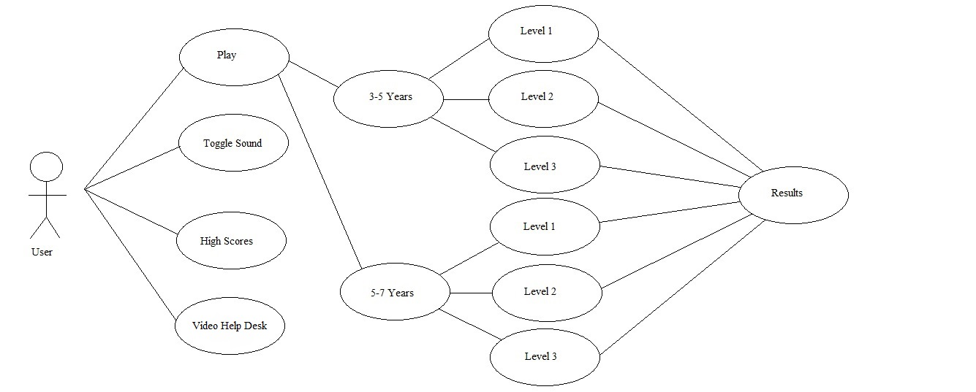

**10.2 Traceability Matrix**

|  |  |  |  |  |  |
| --- | --- | --- | --- | --- | --- |
| **System Requirements:** | **Use Cases:** | | | | |
| 1 | 2 | 3 | 4 | 5 |
| 1 |  |  |  |  |  |
| 2 |  |  |  |  |  |
| 3 |  |  |  |  |  |
| 4 |  |  |  |  |  |
| 5 |  |  |  |  |  |
| 6 |  |  |  |  |  |
| 7 |  |  |  |  |  |
| 8 |  |  |  |  |  |
| 9 |  |  |  |  |  |
| 10 |  |  |  |  |  |
| 11 |  |  |  |  |  |
| 12 |  |  |  |  |  |
| 13 |  |  |  |  |  |
| 14 |  |  |  |  |  |
| 15 |  |  |  |  |  |
| 16 |  |  |  |  |  |
| 17 |  |  |  |  |  |
| 18 |  |  |  |  |  |
| 19 |  |  |  |  |  |
| 20 |  |  |  |  |  |
| 21 |  |  |  |  |  |
| 22 |  |  |  |  |  |
| 23 |  |  |  |  |  |
| 24 |  |  |  |  |  |
| 25 |  |  |  |  |  |
| 26 |  |  |  |  |  |
| 27 |  |  |  |  |  |
| 28 |  |  |  |  |  |

**10.3 Sequence diagram for selecting a quiz based on age**

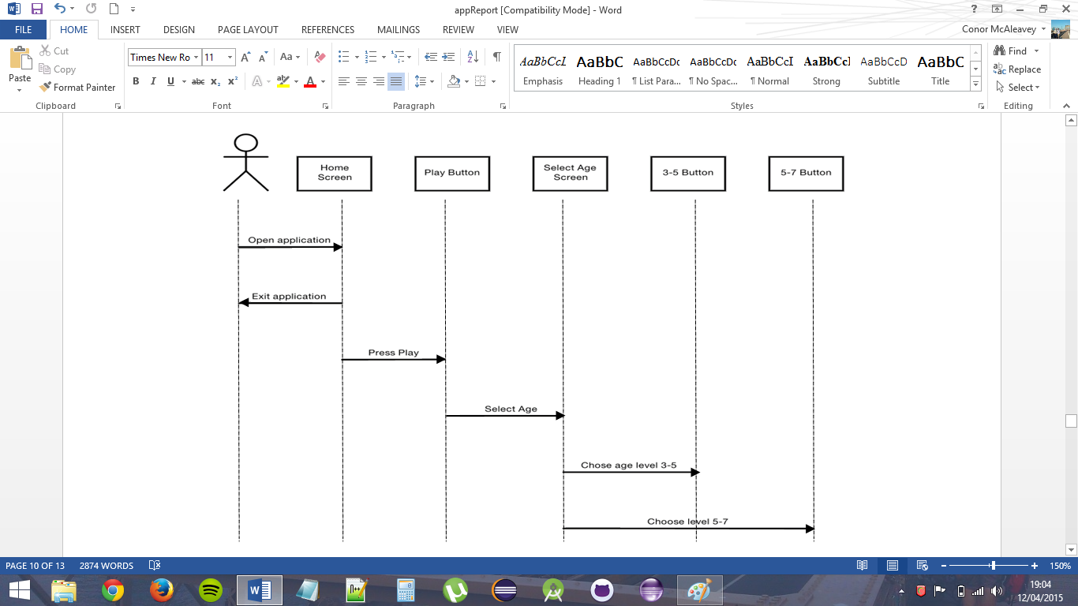

**10.4 Sequence diagram for completing a level and displaying results**

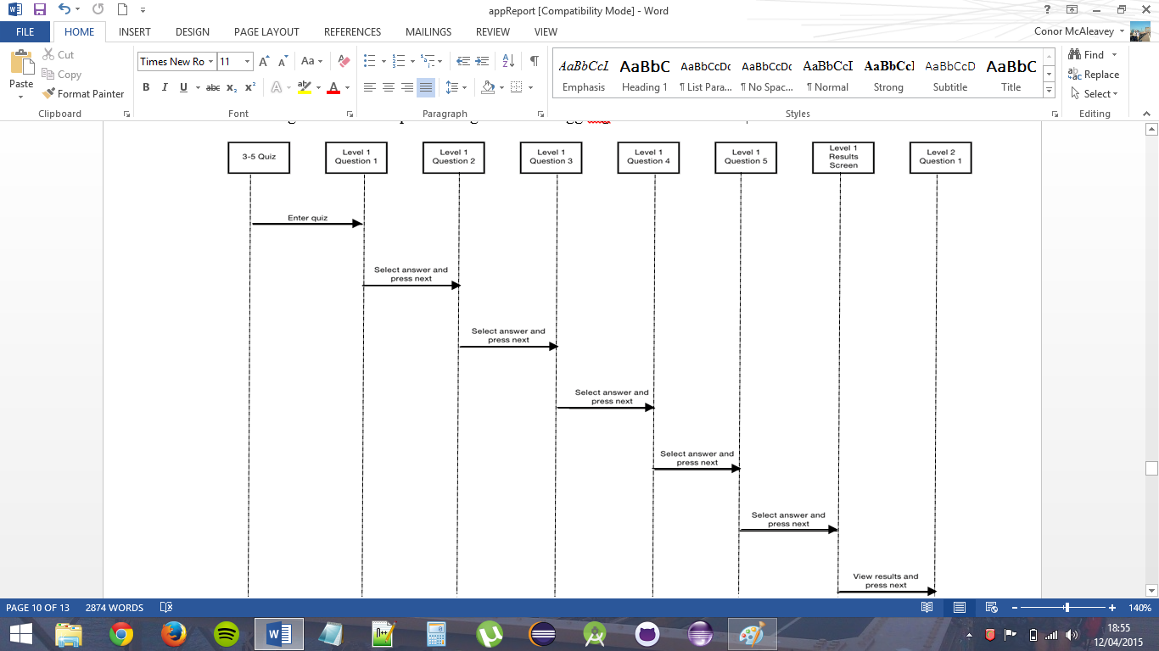

**10.5 Sequence diagram for to toggling the music on or off**

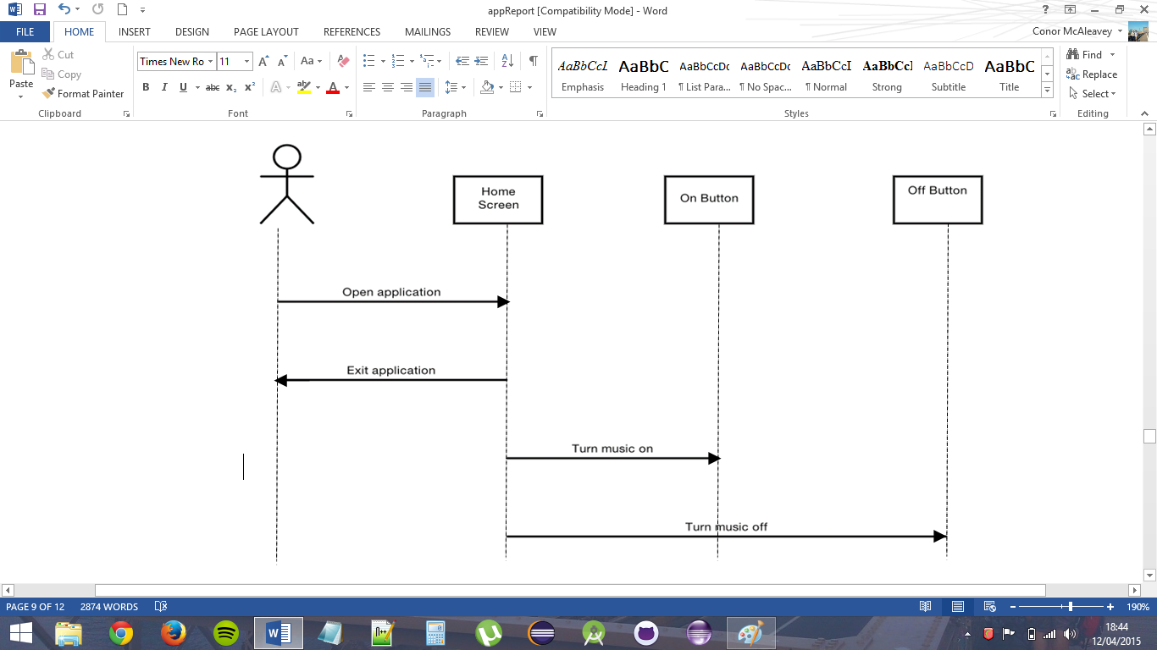

**10.6 Initial Home Screen and Logo Design**



**10.7 Final Home Screen, Select Age, and Select Level Designs**

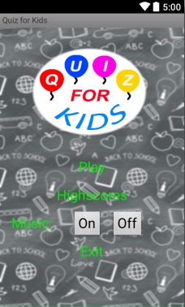

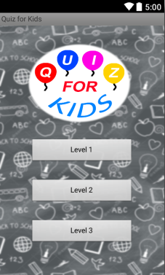

**10.8 Initial Question Screen Design and Different Backgrounds**









**10.9 Final Question Page Design**

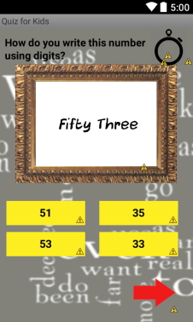

**10.10 Results Page Design**

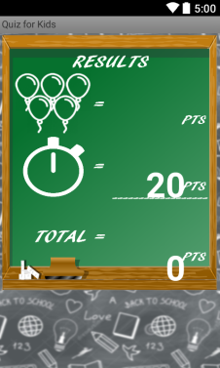



**10.12 Domain Model**

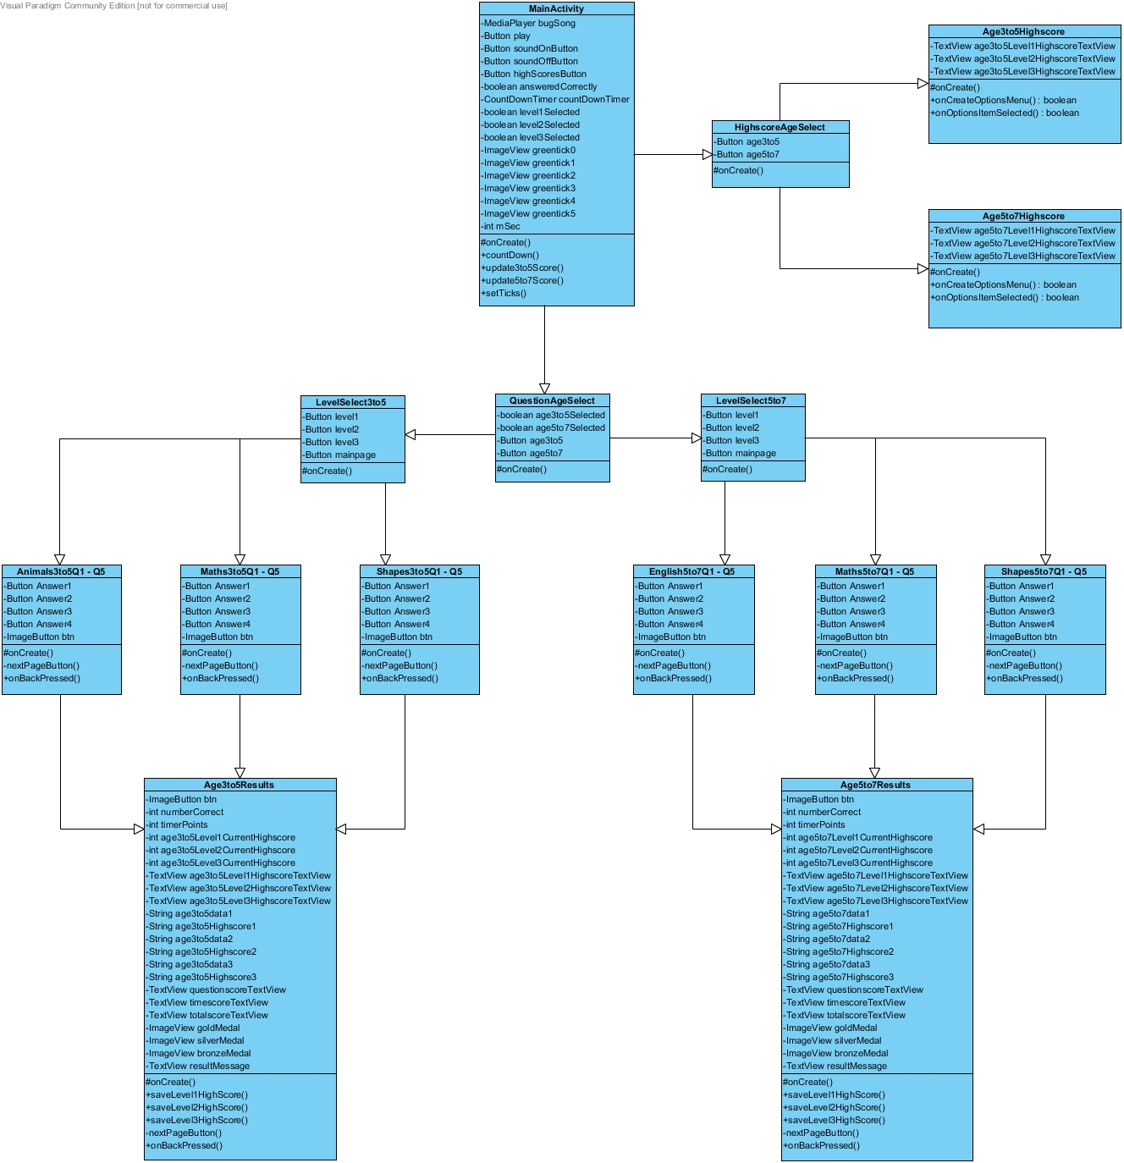

**10.13 System Operations Contract**

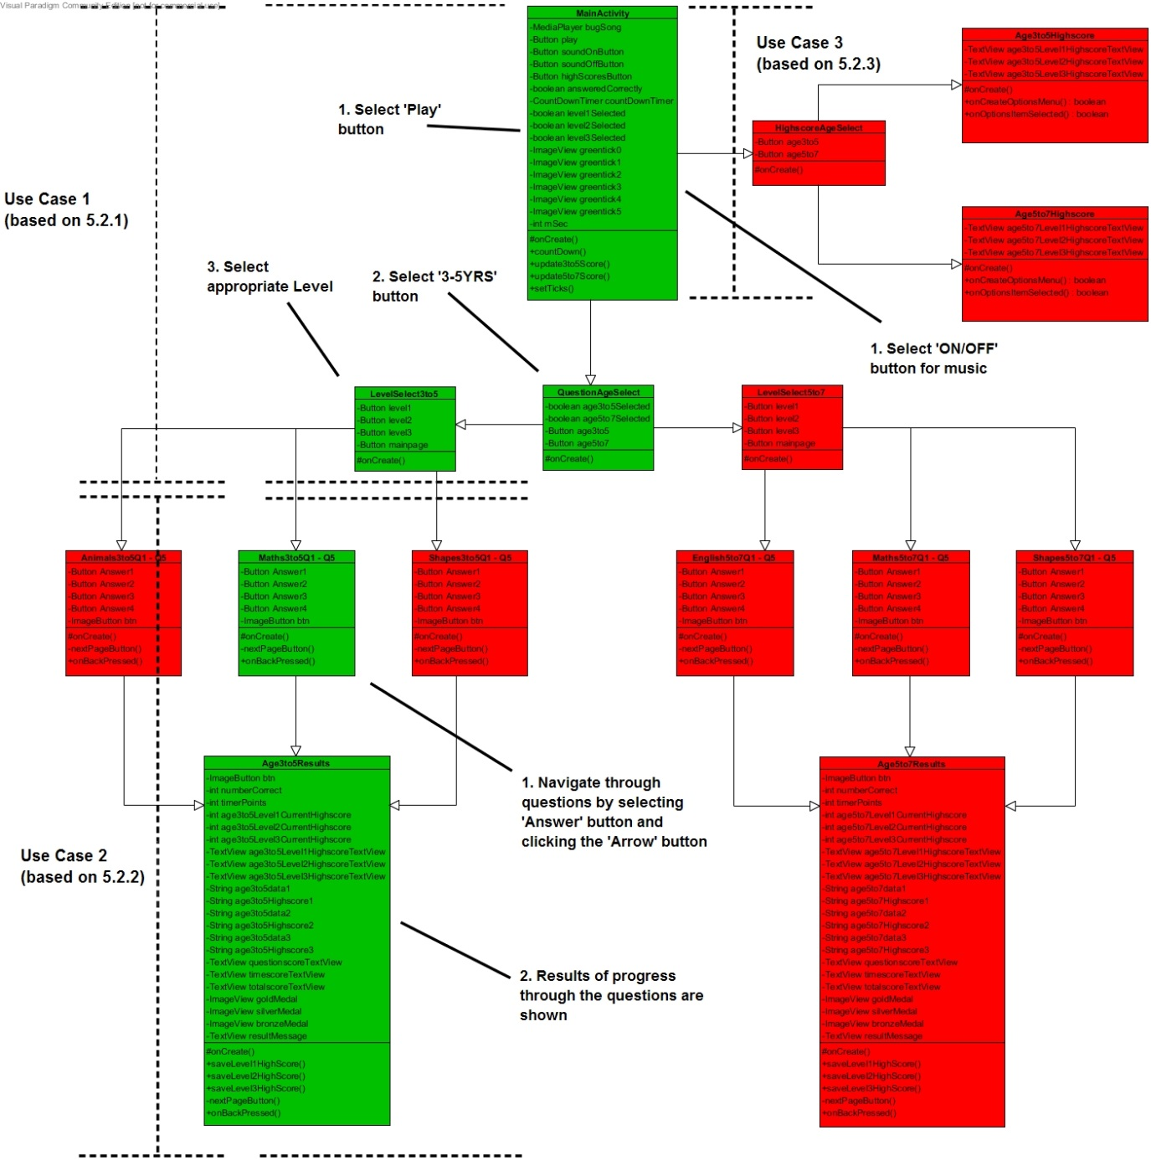

**10.14 Project Deliverables**

|  |  |  |  |  |  |  |  |  |
| --- | --- | --- | --- | --- | --- | --- | --- | --- |
| **Project Deliverables:** | **Week beginning:** | | | | | | | |
| 02/03 | 09/03 | 16/03 | 23/03 | 30/03 | 06/04 | 13/04 | 20/04 |
| Customer Statement of Requirements |  |  |  |  |  |  |  |  |
| System Requirements |  |  |  |  |  |  |  |  |
| Functional Requirements Specification |  |  |  |  |  |  |  |  |
| User Interface Specification |  |  |  |  |  |  |  |  |
| Domain Analysis |  |  |  |  |  |  |  |  |
| *Home* page |  |  |  |  |  |  |  |  |
| Application music |  |  |  |  |  |  |  |  |
| *Select Age* page |  |  |  |  |  |  |  |  |
| *Select Level* pages |  |  |  |  |  |  |  |  |
| *Question* pages |  |  |  |  |  |  |  |  |
| Create Questions |  |  |  |  |  |  |  |  |
| Countdown Timer |  |  |  |  |  |  |  |  |
| *Results* page |  |  |  |  |  |  |  |  |
| Mathematical model for calculating scores |  |  |  |  |  |  |  |  |
| *High Scores* page |  |  |  |  |  |  |  |  |
| Local high scores database |  |  |  |  |  |  |  |  |
| Video Help Desk |  |  |  |  |  |  |  |  |

**10.15 Breakdown of Responsibilities**

|  |  |
| --- | --- |
| Steven Kennedy | Domain Analysis |
| Jonathan Leathem | Customer Statement of Requirements  System Requirements  Functional Requirements Specification  User Interface Specification  Domain Analysis |
| Conor McAleavey |  |
| Chris McClune |  |
| Kevin O’Hare |  |